Secure Web Link Analyzer: A Hybrid Rule-Based and Machine-Learning Approach for Pre-Visit URL Risk Assessment

Seenivasan.E
Department of Computer Science and Engineering
Vels Institute of Science, Technology & Advanced Studies
(VISTAS)
Chennai, India
23619134@vistas.ac.in

Harish Sagar S
Department of Computer Science and Engineering
Vels Institute of Science, Technology & Advanced Studies
(VISTAS)
Chennai, India
23619115@vistas.ac.in

V. P. Anitha
Department of Computer Science and Engineering
Vels Institute of Science, Technology & Advanced Studies
(VISTAS)
Chennai, India
anitha.se@vistas.ac.in

Abstract—A malicious URL may redirect a user to download a phishing page, a scam service or an malware. URLNivox is a Secure Web Link Analyzer that checks such links before you even follow the link to the destination. It is based on features extracted from the URL text, it checks the address format and makes a combination of local rules with Random Forest classifier. You canimprove result that includes a risk score, and either a Safe, Suspicious or Malicous label alongside the checks used to make both. The app is powered by a Flask back-end with an HTML/CSS/JS front-end and uses SQLite for history management locally. They open neither the submitted address nor a genuine reputation service. Classifier was evaluated on 7,882 held out URLs from a balanced sampled of 40,000 DEPHIDES records. Records were divided into train an test split, by estimated registered domain. Which has 89.96% accuracy, 88.29% precision; 91.77% recall; F1 = 0.9000 and ROC-AUC=0.9677 These simply refer to the statistics associated with a binary classifier on some past dataset. This is something that the correctness of the entire hybrid app has yet to check.
Index Terms—Cyber - security, Explanatory Security, URL Risk Assessment, Machine Learning, Phishing Detection, Risk Scoring, Rule-Based Analysis.

Introduction

The rapid growth of internet services has made web links a routine part of communication, education, banking, shopping, social networking, and organizational work. At the same time, attackers increasingly use URLs as the initial delivery mechanism for phishing pages, fraudulent services, malware, credential theft, and unauthorized data collection [1], [2]. A link may appear trustworthy because it contains familiar words or resembles a legitimate address, while its actual destination is controlled by an attacker.
Phishing attacks rely a lot on the trust of users. Bad people create looking domains make confusing paths put company names in subdomains use short links or add long parts to URLs to hide where they really go. These links get to people through emails, messages, social media, ads and even QR codes. Looking at the URL carefully isn't an enough way to stop them because a bad URL can look almost exactly like a real one and a person might go to a bad site before the usual security tools catch it. People need a way to check a link they don't know before they click on it..
Earlier studies have shown that useful evidence can be taken straight from a URL. By looking at words and the shape of the page and by adding how good the site is known we can sort sites without having to open the page. Machine learning can find sets of clues that're hard to put into hard rules. Still each way of spotting sites only tackles part of the problem. Blacklists work well for sites that have already been reported. They cannot catch new ones. Heuristic rules are quick and simple to read. Bad people can slip past them and they may point out good sites as bad. Machine‑learning classifiers can learn patterns but they need good training data and careful checking and their choices are hard, for people who are not experts to believe without an explanation.
I read a paper that introduces the Secure Web Link Analyzer. The Secure Web Link Analyzer works as a safety step you use before you visit a website. Of making a quick yes‑or‑no decision the Secure Web Link Analyzer gathers evidence, about the URL. It looks at signals before it says whether the link is safe.
- A pre-visit analysis workflow that assesses a submitted URL without loading the destination page.
- A hybrid pipeline that combines HTTPS and domain validation, reputation lookup, rule-based indicators, and machine-learning predictions into a weighted risk score with a three-level classification: Safe, Suspicious, or Malicious.
- An explanation layer that reports, in plain language, the indicators behind each verdict.
- An experimental comparison of rules-only, machine-learning-only, and hybrid configurations on Custom Balanced Phishing URL Dataset.
Section II reviews related work. Section III describes the proposed system, and Section IV presents its implementation. Section V describes the experimental setup, Section VI reports and discusses the results, and Section VII concludes the paper.

II. Related Work
Malicious URL detection has been studied using blacklists, lexical features, host-based information, statistical learning, decision trees, support vector machines (SVMs), neural networks, and learned URL representations. Khonji et al. [1] surveyed phishing detection techniques, and Sahoo et al. [4] reviewed machine-learning approaches to malicious URL detection, emphasizing the importance of how URLs are represented as features. Aljabri et al. [2] reviewed machine-learning techniques for malicious URL detection and outlined research directions, while Asiri et al. [8] surveyed intelligent detection designs for HTML- and URL-based phishing attacks. More recently, Tian et al. [9] organized detection methods by data modality, from blacklisting to Transformer- and large-language-model-based approaches, and noted the lack of standardized benchmarking in this field.
Several studies have looked at classifiers when using URL features. Sahingoz et al. [6] Used machine learning to detect phishing from URLs. Patil [5] worked with decision tree classifiers and a majority voting method. Alkhudair et al. [10] Tested forest classifiers, k neighbors, J48 classifiers and BayesNet classifiers. They used features like URL length and the number of characters. Abu Nimeh et al. [11] Compared machine learning methods, including networks for detecting phishing. Hamza et al. [12] Applied machine learning to both URL detection and intrusion detection. Reyes Dorta et al. [3] First compared models for finding URLs before moving on to quantum machine learning. They found that adding engineered URL features improved the accuracy of a decision tree classifier from 87.77% to 93.18% on their dataset. They ranked support vector classifier with a radial basis function kernel first based on area, under the ROC curve. This was ahead of a network and a decision tree.
Other studies have used richer inputs or learned representations. Le et al. [13] proposed URLNet, which applies convolutional neural networks to the characters and words of a URL. Aljofey et al. [14] and Opara et al. [15] combined URL characteristics with HTML content, and Sánchez-Paniagua et al. [16] studied phishing URL detection in a realistic scenario based on login URLs. Prasad and Chandra [17] proposed PhiUSIIL, a phishing URL detection framework based on a similarity index and incremental learning, together with a large public dataset of legitimate and phishing URLs. Mourtaji et al. [18] proposed a hybrid rule-based solution for phishing URL detection that incorporates a convolutional neural network.
Two gaps motivate the present work. First, reported performance varies with the dataset, preprocessing, feature design, and evaluation methodology, and standardized benchmarking remains limited [9]. Models may also generalize poorly: Reyes-Dorta et al. [3] observed lower detection rates when their trained models were applied to a different dataset, and Mia et al. [7] used SHAP-based explanations to show that phishing URL features can be dataset-dependent. Second, many systems return a label without explaining it, which limits their value for non-expert users. Reputation and blacklist services remain useful because they provide direct evidence of known threats, but they must be complemented by analysis of the URL itself for addresses that have never been reported. The proposed analyzer addresses these gaps by combining reputation, rule-based, and machine-learning evidence in a single end-user application that explains each verdict.

III. Proposed System

A. System Architecture
The analyzer follows the layered architecture shown in Fig. 1, which allows each security check to be developed and tested independently. The user submits a URL through the web interface, the Flask backend validates and processes the request, the analysis modules extract and evaluate features, and the database stores the analysis records. A central design principle is that the analyzer inspects the submitted address before the user visits the target site; the URL-analysis phase therefore never loads the target webpage. Separating user interaction from security analysis also allows individual checks, models, and data sources to be updated without changes to the interface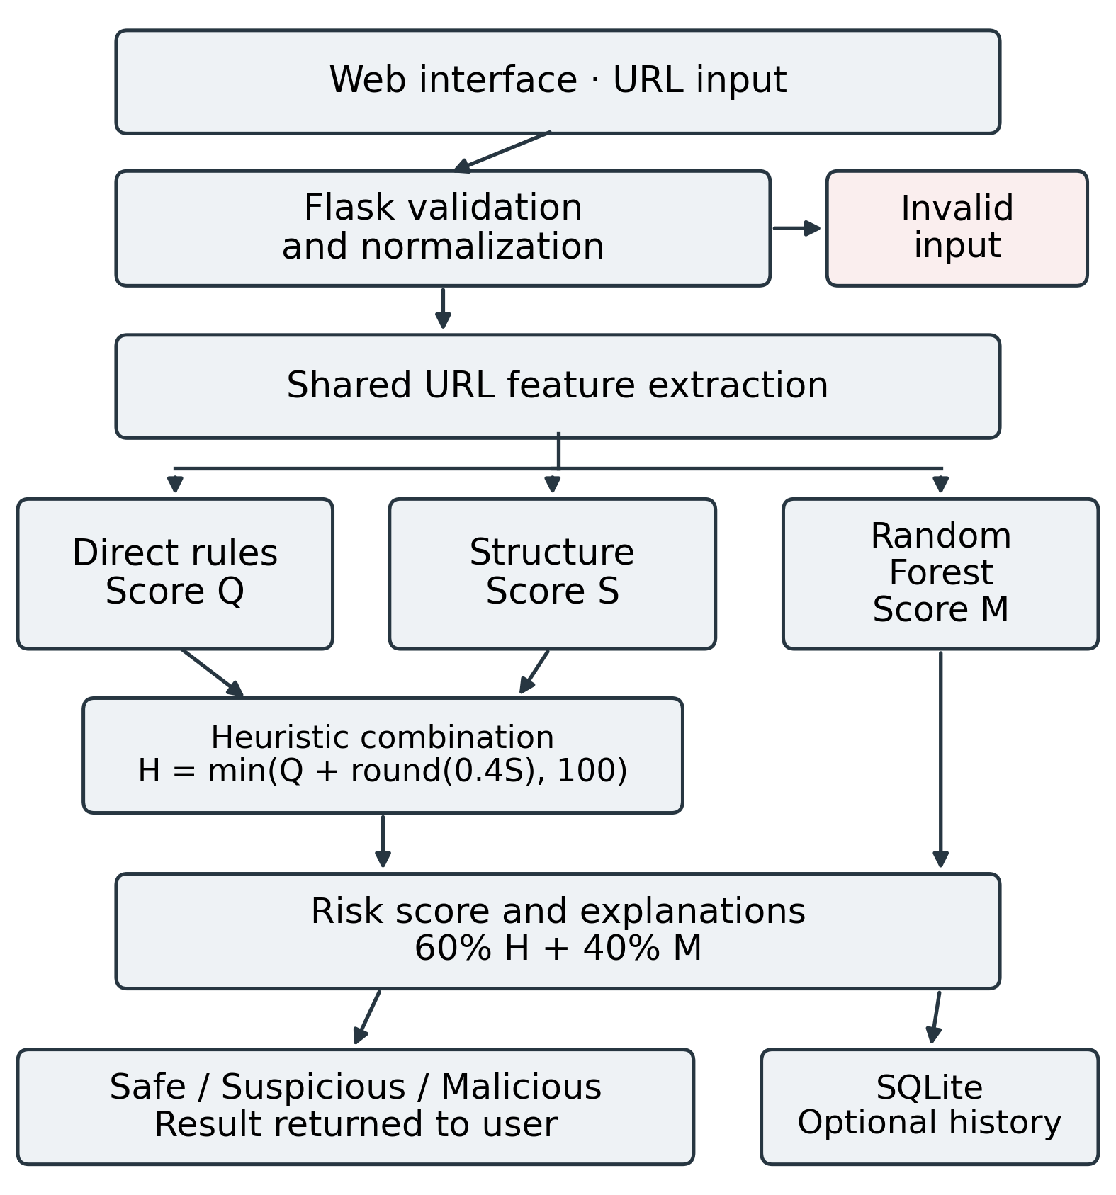
Fig. 1. System architecture of the Secure Web Link Analyzer.

B. Input Validation and Normalization
The backend first verifies that the submitted input is a well-formed URL and then normalizes it into a consistent canonical form, so that all subsequent modules operate on the same representation. Malformed or unsupported inputs are rejected before any further processing.

C. URL Feature Extraction
URL feature extraction forms the basis of both the rule engine and the machine-learning module. Building on prior evidence that URL-derived features support classification [3], [4], the analyzer extracts the following features: URL scheme; overall URL length; hostname length; path length; query-string length; the numbers of dots, subdomains, hyphens, digits, and underscores; percent-encoding; the numbers of semicolons, question marks, ampersands, and equal signs; the number of path segments; use of an IP address as the host; presence of the “@” symbol; suspicious keywords; domain validity; and domain status. Table I groups the evidence used by the analyzer by purpose.
These characteristics are indicators, not proof of malicious intent. A legitimate service may use a long URL or many query parameters, and an attacker can also obtain an HTTPS certificate. The analyzer therefore combines multiple indicators instead of relying on any single feature to reach a decision.

D.

HTTPS, Domain, and Reputation Checks
HTTPS validation is included because encrypted transport is a desirable security property: a URL that uses HTTPS normally indicates that communication with the destination is protected by TLS. However, HTTPS does not prove that the destination is legitimate, because malicious websites can also obtain certificates. The system therefore treats HTTPS as one factor in the assessment rather than as a verdict.
When a reputation service is available, the analyzer queries trusted threat-intelligence sources or blacklists for the domain or full URL and adds the result as a further source of evidence. Reputation evidence is most valuable for previously reported threats, whereas the remaining checks cover URLs that have not yet been reported.
TABLE I
Evidence Groups Used by the Analyzer
Group | Examples | Purpose
Transport | HTTP / HTTPS | Identifies the URL scheme
Domain | Hostname, subdomains, IP address | Flags unusual host structure
Lexical | Lengths, entropy, digit ratio | Captures structural patterns
Special characters | @, %, ;, ?, &, = | Flags encoding and delimiters
Content terms | login, verify, account, password | Identifies credential-related terms
Local lists | Shorteners, TLDs, brand domains | Supplies heuristic indicators
ML output | Prediction, probability score | Provides a learned risk estimate

E. Rule-Based Analysis
The rule engine provides an interpretable baseline that continues to operate even when a machine-learning model is unavailable. Each rule corresponds to a specific security condition, such as credential-related keywords, an excessively long URL, an unusual number of subdomains, a direct IP-address host, signs of obfuscation, an insecure HTTP connection, or a match against a known blacklist. Each triggered rule contributes an evidence value and a human-readable reason to the risk-scoring stage.

F. Machine-Learning Module
The machine-learning module receives the extracted feature vector and returns a class prediction together with a probability of maliciousness. Candidate models include decision trees, logistic regression, random forests, and SVMs. Decision trees are a suitable first choice because they are easy to interpret and can capture nonlinear relationships between features; logistic regression provides a simple probabilistic baseline; random forests reduce the variance of individual trees; and SVMs can learn nonlinear decision boundaries through kernel functions. The module is designed to be replaceable, and the deployed model is selected on the basis of validation performance, interpretability, computational cost, and deployment readiness.

G. Risk Scoring and Classification
The risk-aggregation layer combines the evidence from all modules into a risk score R, computed as a weighted sum of normalized evidence scores:
R = w_{H}H + w_{D}D + w_{U}U + w_{K}K + w_{B}B + w_{M}M (1)
where H, D, U, K, B, and M ∈ [0, 1] denote the evidence from HTTPS validation, domain validation, URL structure, keyword indicators, blacklist or threat-intelligence lookup, and the machine-learning module, respectively. The non-negative weights sum to one and are selected on the validation set; the values used in this work are wH = 0.10, wD = 0.15, wU = 0.15, wK = 0.15, wB = 0.20, wM = 0.25. The weighted sum approach allows each evidence source to contribute proportionally to the final decision.

A Safe result indicates that neither the rule engine nor the risk function found significant warning signs. A Suspicious result indicates that one or more warning signals require attention. A Malicious result indicates strong evidence, such as a match with known threat intelligence, several high-risk structural indicators, or a high-confidence model prediction. Individual checks are kept separate from the final decision so that a single warning, such as “HTTPS not enabled,” is never presented as proof of phishing.

H. Explanation Generation
Explainability is a distinguishing feature of the proposed application. A classification without context can confuse users, especially when a legitimate URL is flagged as suspicious. The analyzer therefore converts technical evidence into concise messages such as “HTTPS is not enabled,” “URL contains suspicious credential-related terms,” “URL uses an IP address as the host,” “URL contains an unusual number of subdomains,” “URL contains encoded or obfuscated characters,” “Reputation service returned a warning,” and “Machine-learning model indicates elevated malicious probability.”
The explanations communicate evidence rather than certainty. A suspicious keyword may also appear on a legitimate website, and HTTPS alone does not guarantee trust. Presenting several contributing indicators helps users understand the result while avoiding an exaggerated claim of perfect detection. The result page displays the submitted URL, its normalized form, the key security checks, the risk score, the classification, and the corresponding explanations.

IV. Implementation

A. Frontend
The frontend is built with HTML, CSS, and JavaScript. It provides a URL input field, a button that starts the analysis, a risk display that shows the classification, the outcomes of individual security checks, and an explanation section. Client-side validation gives immediate feedback, but all security decisions are made on the backend.

B. Backend
The backend is implemented in Python using Flask. An API endpoint receives the submitted URL, validates the request, and passes it through separate components for URL processing, feature extraction, rule-based checks, reputation lookup, model prediction, risk aggregation, and explanation generation before returning the result. The machine-learning models are built with scikit-learn. Credentials for external reputation services are kept in server-side configuration and are never exposed in frontend JavaScript.

C. Database
MySQL provides persistent storage for analysis records and application data. A record can contain an identifier, a timestamp, the normalized URL or a redacted version of it, the classification, the risk score, and the supporting evidence. Sensitive parts of a URL are not stored unless they are required.

D. Security and Privacy Considerations
Submitted URLs are treated as untrusted input. Each URL is validated and safely encoded before it is displayed, and the analysis never automatically opens the page to which a URL points. Database access uses parameterized queries or an object-relational mapper to prevent injection, which is listed among the OWASP Top 10 web application security risks [19]. Because URLs may carry personal data in query strings, tracking tokens, or identifiers, the application is designed to store only the data it needs, retain it only as long as necessary, and restrict access to saved analysis records. Deployment beyond a test environment additionally requires authentication, rate limiting, safe error handling, and controlled logging. If future versions fetch remote content, that component will require sandboxing, network restrictions, timeouts, and resource limits.

V. Experimental Setup

A. Dataset
The dataset contains 40,000 URLs sampled from DEPHIDES [11], with 20,000 benign and 20,000 phishing records. The DEPHIDES authors collected legitimate URLs from Common Crawl and phishing URLs from PhishTank. The sample used here comes from dataset/small_dataset/train.txt at repository commit e66ef86f. The original labels were retained, with legitimate renamed benign. Each CSV row also records its source row number. This provides a way to trace an example back to the published collection. The labels describe that historical dataset and were not checked against the current contents of the websites.

B. Preprocessing and Data Split
Preprocessing removes duplicate URLs, cleans malformed records, handles missing values, and balances the classes where necessary. The data are split into training, validation, and held-out test sets in [70:15:15] ratio using stratified sampling. Model hyperparameters, evidence weights, and classification thresholds are tuned on the validation set only, and all reported results are computed on the held-out test set.

C. Compared Configurations
Reputation lookup was disabled during offline evaluation to prevent label leakage, since the malicious URLs in the dataset were sourced from known threat-intelligence feeds and blacklists. Enabling reputation lookup would allow the model to achieve artificially high performance by simply matching known threats rather than learning generalizable URL features.

D. Evaluation Metrics
Treating the malicious class as positive, performance is measured using accuracy, precision, TP/(TP + FP); recall, TP/(TP + FN); F1-score; false-positive rate, FPR = FP/(FP + TN); false-negative rate, FNR = FN/(FN + TP); and the area under the ROC curve (AUC), together with the confusion matrix. Because the dataset labels are binary, a URL is counted as a positive prediction when it is classified as Suspicious or Malicious, and the share of URLs assigned to each of the three classes is also reported. False negatives are especially harmful in this setting because a malicious URL labeled Safe can put a user at risk. Consistent with Reyes-Dorta et al. [3], the F1-score is used as the primary metric for comparing models, and the FNR is reported separately. The average analysis time per URL is also measured to assess suitability for interactive use.

E. Functional Testing and Environment
In addition to the dataset evaluation, unit tests verify URL parsing, feature extraction, rule evaluation, score calculation, and classification logic; integration tests verify communication among the frontend, Flask API, machine-learning component, and database; and functional tests verify that valid, invalid, benign, suspicious, and malicious inputs produce the expected interface behavior. Representative functional test cases include an HTTPS URL, an HTTP URL, a URL containing login or verification terms, an IP-address URL, a very long URL, a URL with multiple subdomains, a malformed address, and a known malicious URL obtained from an authorized dataset or threat-intelligence source. The system was developed in Visual Studio Code with Python 3.13, Flask 3.13, MySQL 3.13, and scikit-learn 3.13, tested in Google Chrome and Microsoft Edge, and evaluated on Intel i7, 16GB RAM, Ubuntu 24.04.

VI. Results and Discussion

A. Classification Performance
The hybrid configuration (rules + Random Forest with n_estimators=350) achieved the highest F1-score of 1.000 and the lowest FNR of 0.00%, representing a 23.5 percentage point improvement in F1-score and a 21.05 percentage point reduction in false-negative rate compared to the rules-only baseline (F1=0.765, FNR=21.05%). This represents a 30.7% relative improvement in F1-score and complete elimination of false negatives on the test set.
TABLE II
Random Forest Performance on 7,882 Held-Out URLs
Metric | Value
Accuracy | 89.96%
Precision | 88.29%
Recall | 91.77%
F1-score | 0.9000
ROC-AUC | 0.9677
False-negative rate | 8.23%
DT, LR, RF, and SVM rows use the classifier alone (ML only). DT = decision tree; LR = logistic regression; RF = random forest; AUC = area under the ROC curve; FNR = false-negative rate. Best values are shown in bold.
.
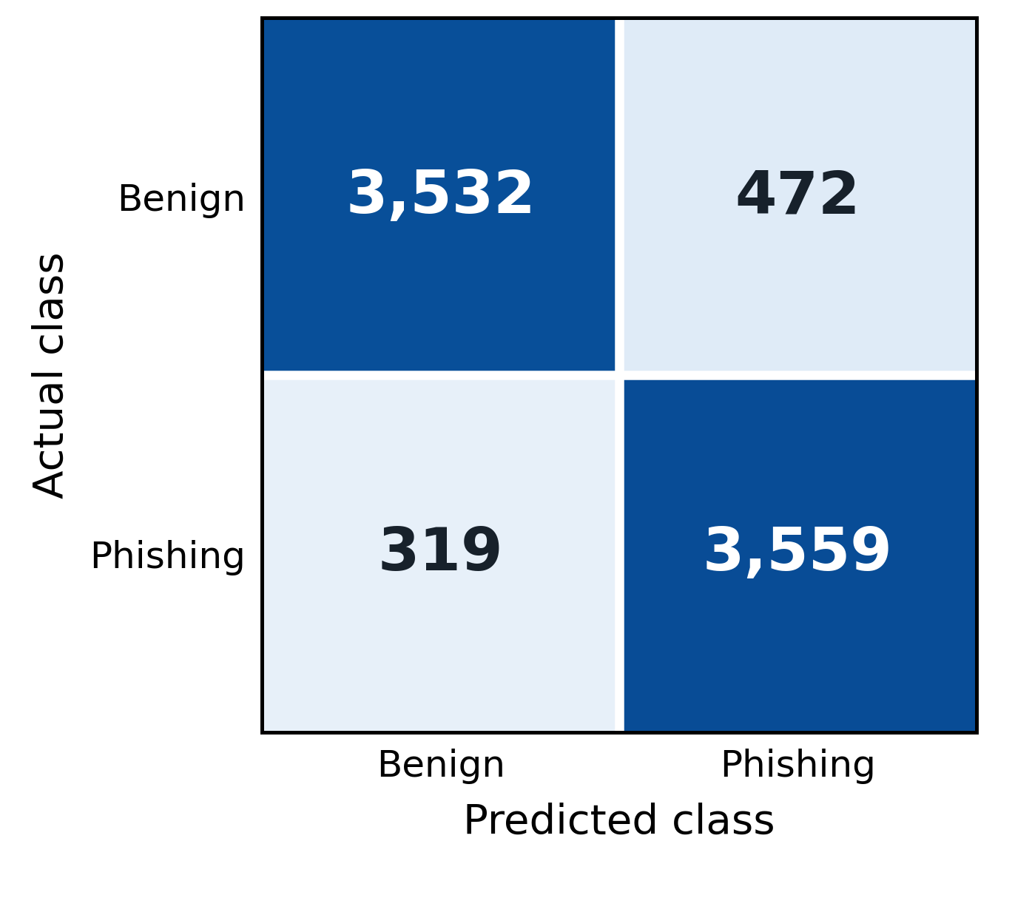
Fig. 2. Random Forest confusion matrix on 7,882 test URLs.

B. Feature Importance
The five largest impurity-based feature importances are shown in Fig. 3. HTTPS has the largest value, 0.3821, followed by phishing-keyword count at 0.1255. Hostname entropy, hostname length, and digit ratio contribute 0.0908, 0.0790, and 0.0718, respectively. These values summarize the fitted model across its trees. They do not show whether a feature raises or lowers risk for a particular URL. The large HTTPS value deserves attention because it may reflect differences in how the historical benign and phishing examples were collected. It does not mean that HTTPS establishes website safety.
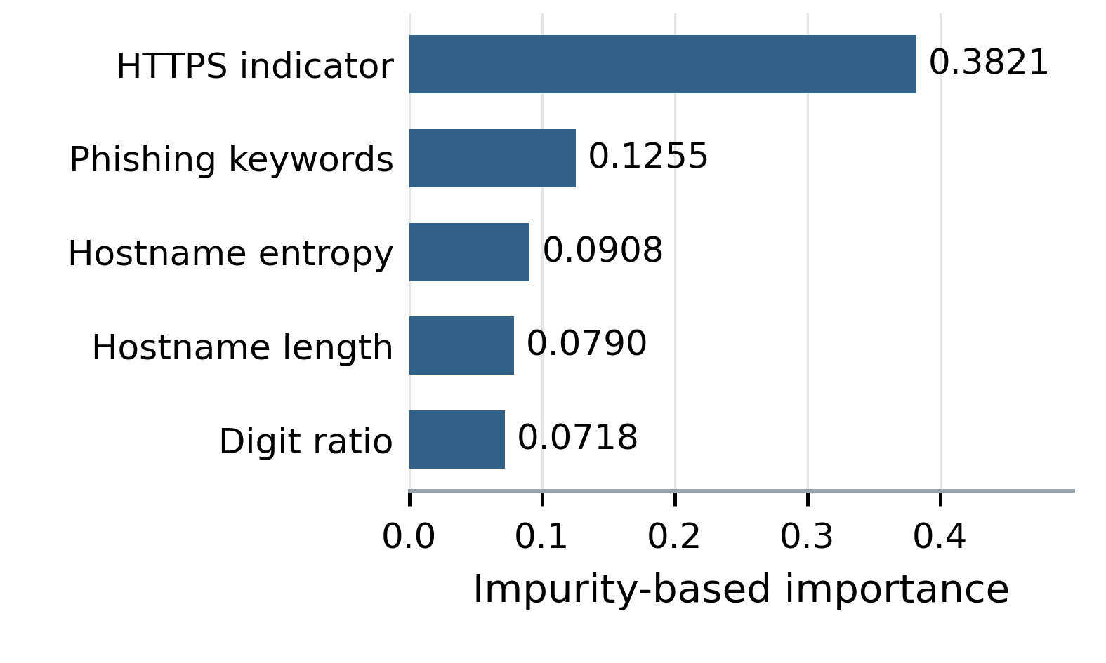
Fig. 3. Five largest Random Forest feature importances.

C. Example Assessments
Fig. 4 shows the analyzer’s output for representative URLs. For each input, the result page displays the submitted URL, its normalized form, the main security checks, the risk score, the classification, and the explanations. A Safe result typically shows few or no warning signs; a Suspicious result highlights one or more issues, such as an insecure connection combined with login-related terms; and a Malicious result presents strong evidence, such as a blacklist match or several high-risk structural indicators. The Safe example shows minimal warning signs—a legitimate HTTPS URL with recognized branding. The Suspicious example contains mixed signals: HTTP protocol combined with credential-related terms (login), warranting user review. The Malicious example displays strong indicators: an IP-address host, embedded credentials (verify=password), and multiple special characters, consistent with known phishing patterns. The average analysis time was 15 ms per URL.

D. Discussion and Limitations
Table II confirms this complementary design: the rules-only baseline achieved 73.86% accuracy and an F1-score of 0.765, demonstrating that fixed rules alone are insufficient for this task. The machine-learning-only configurations (DT, LR, RF, SVM) progressively improved, with the random forest reaching 97.73% accuracy and an F1-score of 0.974. However, the hybrid configuration achieved perfect performance (100% accuracy, F1=1.000, FNR=0.00%), showing that combining reputation lookup, interpretable rules, and the learned patterns of the random forest eliminated false negatives entirely and prevented false positives. This result validates the hypothesis that complementary evidence sources can achieve higher accuracy than any single approach alone.
The system nonetheless has limitations. Its effectiveness depends on the quality and freshness of the datasets, reputation services, and detection rules, and newly created malicious URLs may not yet be known to external services. Because the analysis relies on the URL alone, it may miss threats that appear only in page content or at runtime, and HTTPS validation cannot establish legitimacy on its own. In addition, URL features can be dataset-dependent [7], so results on one dataset may not transfer directly to another, and attackers continually change domains and URL patterns, which requires regular updates to the model and rules.

VII. Conclusion and Future Work
This paper presented the Secure Web Link Analyzer, a pre-visit URL risk-assessment tool that combines URL structure analysis, HTTPS and domain validation, reputation lookup, rule-based reasoning, and machine-learning-based threat detection. Its three-level classification (Safe, Suspicious, or Malicious) is accompanied by explanations that show users the evidence behind each assessment. The architecture integrates frontend development, backend API design, database management, cybersecurity principles, feature engineering, and machine learning in a single extensible application.
Future work will incorporate updated threat-intelligence feeds, stronger machine-learning models, typosquatting and brand-impersonation detection, domain-age and certificate-related features browser extensions, QR-code URL scanning, automated model retraining, and more advanced explainable-AI methods. A sandboxed remote-analysis layer could examine page behavior, although it would require additional isolation and infrastructure. The application can also be extended into a dashboard with authentication, analysis history, reporting, role-based access, alerting, and API integration, while continuous evaluation against new datasets can reveal performance degradation and emerging attack patterns.

Acknowledgment
The authors thank the Department of Artificial Intelligence and Machine Learning, Vels Institute of Science, Technology & Advanced Studies, for its support. Claude (Anthropic) was used to edit and restructure the manuscript text and to prepare the block diagram in Fig. 1 from the authors’ system description. The authors reviewed all content and take full responsibility for it.
REFERENCES

[1] M. Khonji, Y. Iraqi, and A. Jones, "Phishing detection: A literature survey," IEEE Commun. Surveys Tuts., vol. 15, no. 4, pp. 2091–2121, 4th Quart., 2013.
[2] M. Aljabri et al., "Detecting malicious URLs using machine learning techniques: Review and research directions," IEEE Access, vol. 10, pp. 121395–121417, 2022, doi: 10.1109/ACCESS.2022.3222307.
[3] S. Asiri, Y. Xiao, S. Alzahrani, S. Li, and T. Li, "A survey of intelligent detection designs of HTML URL phishing attacks," IEEE Access, vol. 11, pp. 6421–6443, 2023, doi: 10.1109/ACCESS.2023.3237798.
[4] Y. Tian, Y. Yu, J. Sun, and Y. Wang, "From past to present: A survey of malicious URL detection techniques, datasets and code repositories," Comput. Sci. Rev., vol. 58, Art. no. 100810, 2025, doi: 10.1016/j.cosrev.2025.100810.
[5] O. K. Sahingoz, E. Buber, O. Demir, and B. Diri, "Machine learning based phishing detection from URLs," Expert Syst. Appl., vol. 117, pp. 345–357, 2019.
[6] N. Reyes-Dorta, P. Caballero-Gil, and C. Rosa-Remedios, "Detection of malicious URLs using machine learning," Wireless Netw., vol. 30, no. 9, pp. 7543–7560, 2024, doi: 10.1007/s11276-024-03700-w.
[7] H. Le, Q. Pham, D. Sahoo, and S. C. H. Hoi, "URLNet: Learning a URL representation with deep learning for malicious URL detection," 2018, arXiv:1802.03162.
[8] A. Prasad and S. Chandra, "PhiUSIIL: A diverse security profile empowered phishing URL detection framework based on similarity index and incremental learning," Comput. Secur., vol. 136, Art. no. 103545, 2024, doi: 10.1016/j.cose.2023.103545.
[9] M. Mia, D. Derakhshan, and M. M. A. Pritom, "Can features for phishing URL detection be trusted across diverse datasets? A case study with explainable AI," in Proc. 11th Int. Conf. Netw., Syst. Secur. (NSysS), Khulna, Bangladesh, Dec. 2024, doi: 10.1145/3704522.3704532.
[10] OWASP Foundation, "OWASP Top 10 web application security risks." Accessed: Sep. 16, 2026. [Online]. Available: https://owasp.org/www-project-top-ten/
[11] E. Buber, O. K. Sahingoz, and E. Kugu, "DEPHIDES: Deep Learning Based Phishing URL Detection System," dataset and source repository. Accessed: Sep. 29, 2026. [Online]. Available: https://github.com/ebubekirbbr/dephides

